

DRAFT
Technical Design

Melbourne IT OFC
MIT Credit Card Transaction ReportMIT Credit Card Transaction Report

Author: Tony Whelan
Creation Date: 26 April 2017
Last Updated: 27 April 2017
Version: 1.0
Table of Contents

1. Requirement 3
2. Solution Overview 3
3. Technical Objects 4
3.1 BI Publisher XML Data Definition File 4
3.2 BI Publisher RTF Report Template 4
4. Configuration 4
4.1 Define Value Sets 4
4.2 Define Concurrent Program 5
4.3 Define XML Data Definition 7
4.4 Define XML Template 7
4.5 Update Request Group 7
5. Report Execution 9

Requirement

Melbourne IT has a requirement for a Credit Card Transaction Report to assist with the payment and reconciliation of Credit Card transactions for credit card providers Visa and Amex.

Solution Overview

The MIT Credit Card Transaction Report has been developed and configured using the Oracle EBS XML BI Publisher. This document describes the configuration and execution of XML Report MIT Credit Card Transaction Report to provide the required credit card information.

Technical Objects

BI Publisher XML Data Definition File
This file contains the SQL query, data elements and parameters for the report.
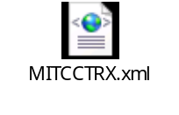

BI Publisher RTF Report Template
This file contains the xml markup and report layout definition for the report.


Configuration

Define Value Sets
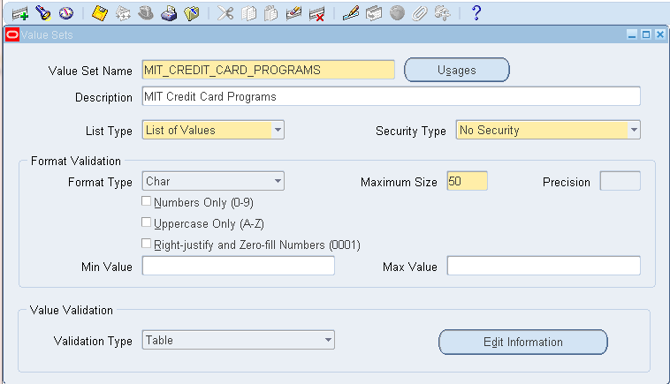

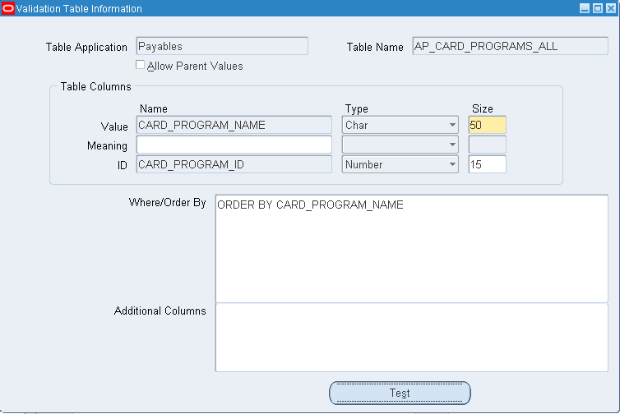

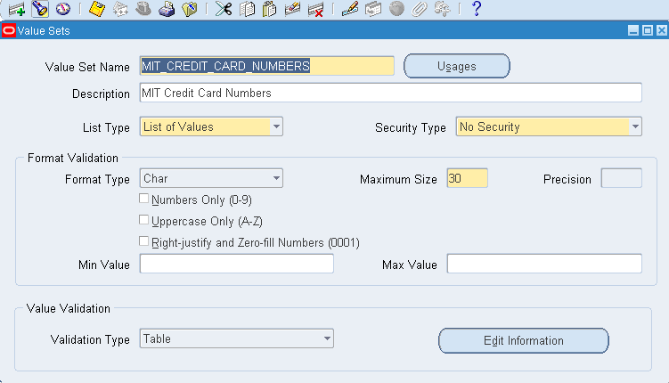

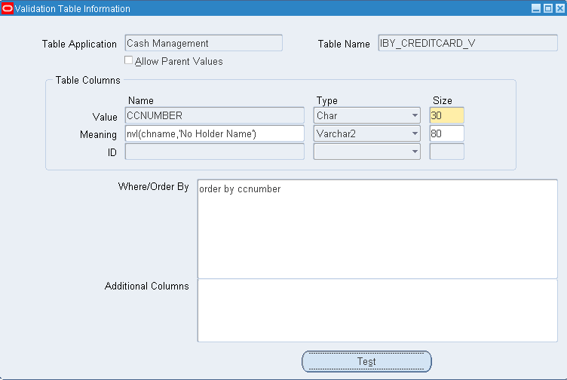

Define Concurrent Program
Responsibility: System Administrator
Menu Path: Concurrent -> Program -> Define
Form: Concurrent Program
Purpose: Define a new concurrent program.
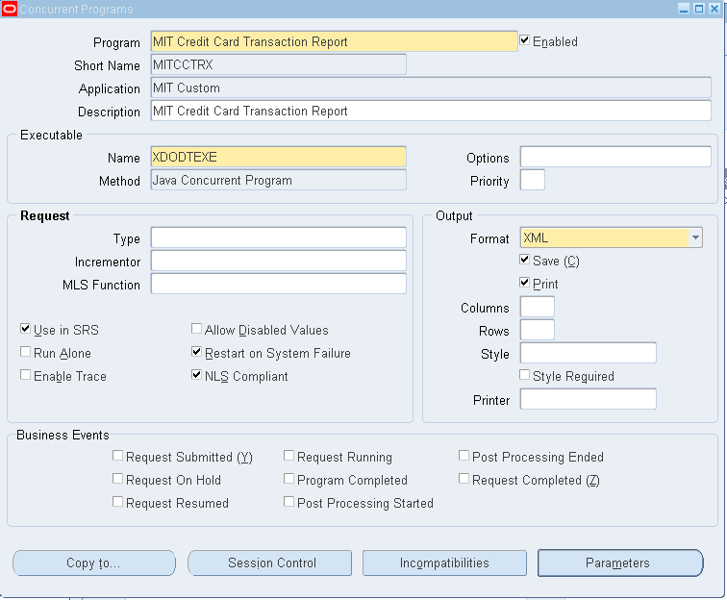

Parameters:
No | Parameter | Value Set | DispSize | Prompt | Token
10 | Credit Card Program | MIT_CREDIT_CARD_PROGRAMS | 50 | Credit Card Program | P_CARD_PROGRAM_ID
20 | Credit Card Number | MIT_CREDIT_CARD_NUMBERS | 30 | Credit Card Program | P_CARD_PROGRAM_ID
30 | Transaction Date From | FND_STANDARD_DATETIME | 20 | Transaction Date From | P_TRANSACTION_DATE_FROM
40 | Transaction Date To | FND_STANDARD_DATETIME | 20 | Transaction Date To | P_TRANSACTION_DATE_TO
50 | Billed Date From | FND_STANDARD_DATETIME | 20 | Billed Date From | P_BILLED_DATE_FROM
60 | Billed Date To | FND_STANDARD_DATETIME | 20 | Billed Date To | P_BILLED_DATE_TO

Define XML Data Definition
Responsibility: XML Publisher
Menu Path: Home -> Data Definitions
Form: Data Definition
Purpose: Define the Data Definition in XML Publisher; attach the XML Data Definition file.

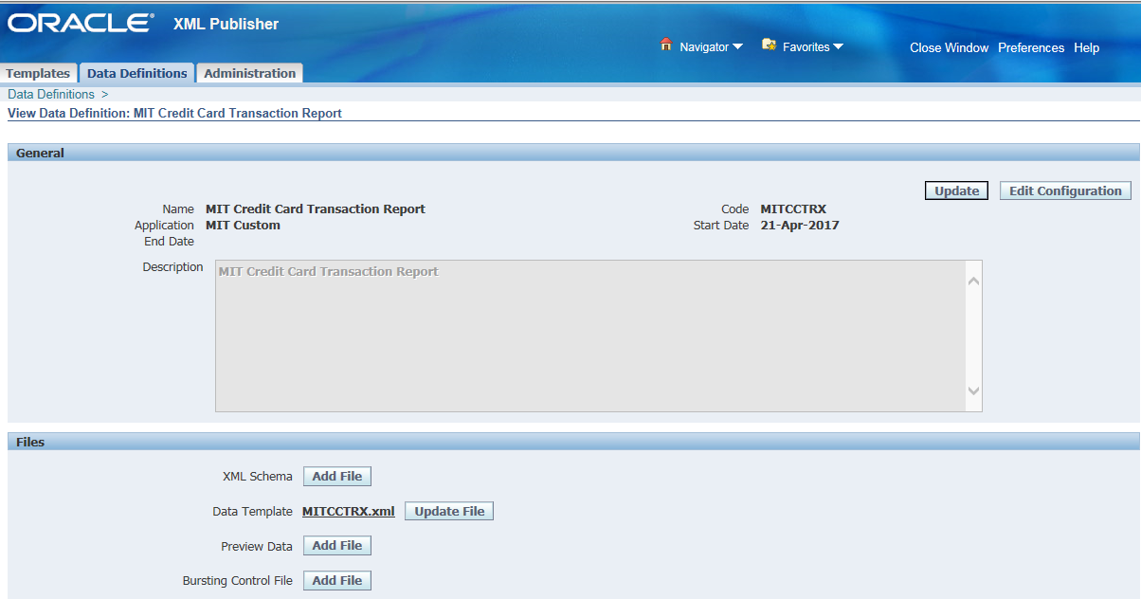

Define XML Template
Responsibility: XML Publisher
Menu Path: Home -> Templates
Form: Templates
Purpose: Define the Layout Template; attach the RTF Report Template file.

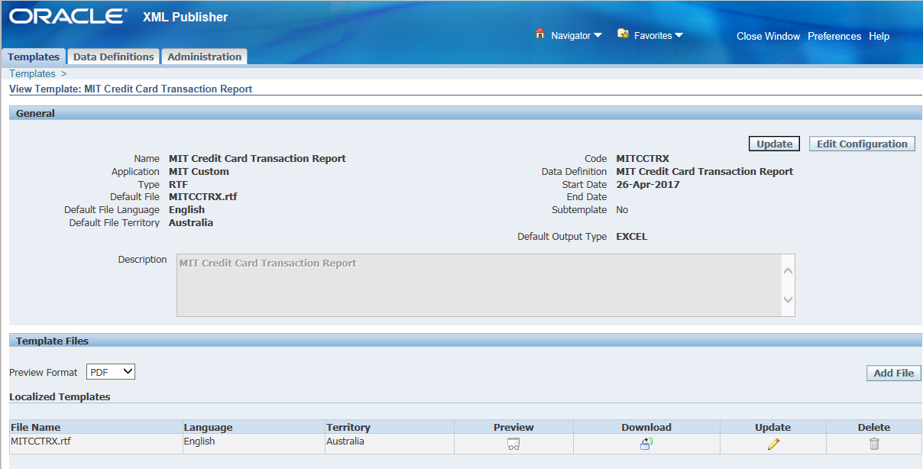

Update Request Group
Responsibility: System Administration
Menu Path: Security-> Responsibility -> Define
Form: Request Group
Purpose: Add the Report to the General Ledger Request Group

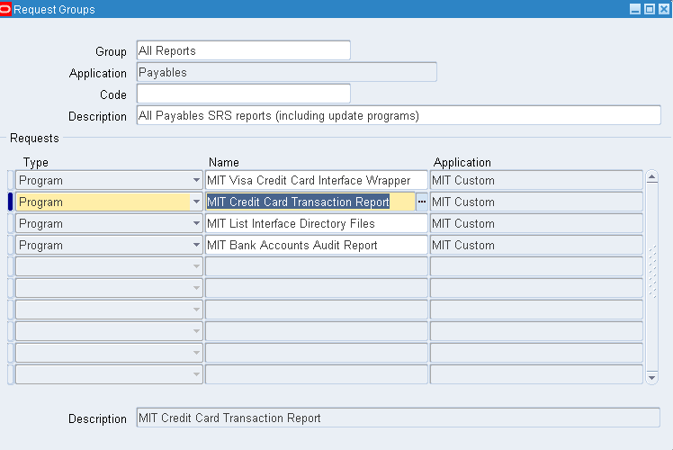

Report Execution

- Login to your OFC Accounts Payables Responsibility and execute the Concurrent Requests program.

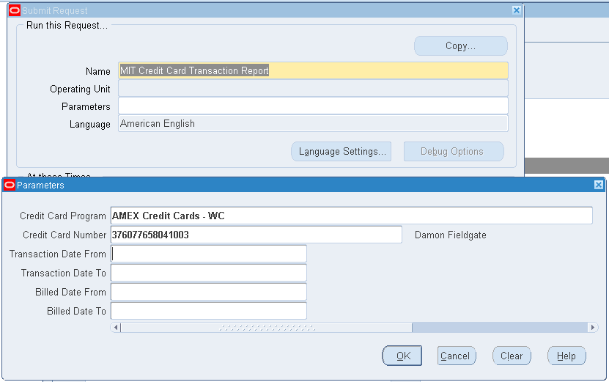

- Enter or select MIT Credit Card Transaction Report.
- Enter or select the required Parameters for the report data:-
  - Credit Card Program (optional)
  - Credit Card Number (optional)
  - Transaction Date From (optional)
  - Transaction Date To (optional)
  - Billed Date From (optional)
  - Billed Date To (optional)
- Submit the Report.
- Execute the View -> Requests menu.
- Click the View Output button in OFC Requests form
- Click the Open or Save option in the Internet Explorer window. This will save the report in your standard Downloads folder.

- Navigate to your Downloads folder and open the report file.

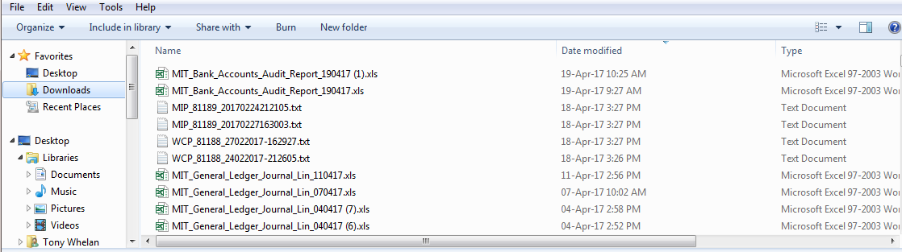

- Click ‘Yes’ to ignore the file format extension warning.
- The report output will be displayed in Excel format as displayed:

